WEBSITE, ONLINE PRESENCE AND SOCIAL MEDIA

MOFA Architects

UMAYMAH SIGBATHULLA

*Freelance Architect*

*Designer and Content Writer*

**DIFFERENT SOCIAL MEDIA PLATFORMS**

1. Website – Generates a single all-information site
2. App for Website
3. LinkedIn – To promote the projects and work ethic at Mofa
4. Instagram – To generate a go-to page for younger architects and new clients
5. Facebook – Generating a bigger audience
6. Twitter – Attracting a bigger audience

**MARKETING STRATEGIES (source: digitallibertyindia.com)**

1. Content marketing – To build relationships on trust. Trust drives revenue.
2. Inbound marketing - Making your company easy to find for the people who need your help.
3. Social media marketing - The first rule of social media is that everything changes all the time. What won’t change is the community’s desire to network.
4. Search engine optimization - Getting targeted and relevant traffic.
5. Search engine marketing/PPC - Nobody counts the number of ads you run. They just remember the impression you make.
6. Account-based marketing (ABM) and retargeting - A lot of people top and tail content to 'personalize' it. True ABM content will transform what your customer is doing, it drives change and an emotional connection.
7. Earned media and PR - Reputation matters because your past is always behind you.
8. Referral programs - Nothing influences people more than a recommendation from a trusted friend.
9. Industry events- Wonderful things can be achieved with teamwork and collaboration.
10. Website & graphic design services - There are three responses to a piece of design, yes, no, and WOW! Wow is the one to aim for.

**WEBSITE PRECURSORS**

**Things to Focus On:**

## Target audience

1. Marketing message
2. Purpose of the website
3. The site as an economic opportunity
4. Brand identity

**Requirements For Quick Pick Up In The Market:**

## Traction

## Branding strategy

1. Marketing plan
2. Platforms to post on
3. Consistent posts (for a year at least)

**Parameters:**

## Analytics

1. Bounce Rate

## Landing Page

## Content

## Site Traffic

## A/B Testing

## Eye Tracking

## Site Speed

**Important Features:**

## Security

## Navigation

## Appearance

1. Mobile Friendly

**WEBSITE CONTENTS**

1. PAGE 1: HOME PAGE
2. Overview and Employment Relationship:

MOFA Architects is an architectural firm intent on being a great place to work for Architects and other professionals who are driven by excellence and a great work ethic. *(Source: MOFA Handbook)*

1. Vision, Mission and Values:

At MOFA Architects we believe in delivering innovation and inspiring and sustainable designs with on-time delivery, for our clients. *(Source: MOFA Handbook)*

1. Company Overall Goals:

Our goal is to be an interdisciplinary local firm with global standards to design smarter and sustainable solutions. *(Source: MOFA Handbook)*

1. About the firm:

MOFA Architects was established almost a decade ago by Ar. Mohammed Faisal. At the time of its inception, there were only five architects. Now the strength has grown to about 10 architects and 8 interns. The firm specialises in residential architecture and master planning. Other fields of involvement of the firm are urban design, landscape architecture, interior design and architecture. Multi-faceted and engaged in improving construction and sustainability standards, the team at Mofa see projects through from beginning to end with utmost care and involvement. The firm boasts a strong work ethic environment and a focused work culture. Hard work and efforts are valued and appreciated. The employees are provided with growth opportunities, both as an architect and as an individual. Work hours are from 9 am to 6 pm. One is free to continue working after the official hours to meet deadlines. *(Source: Self Write-up)*

1. Services provided:

Master Planning, Architecture, Urban Design, Landscape Design, Interior design

1. Office-Pet Friendly

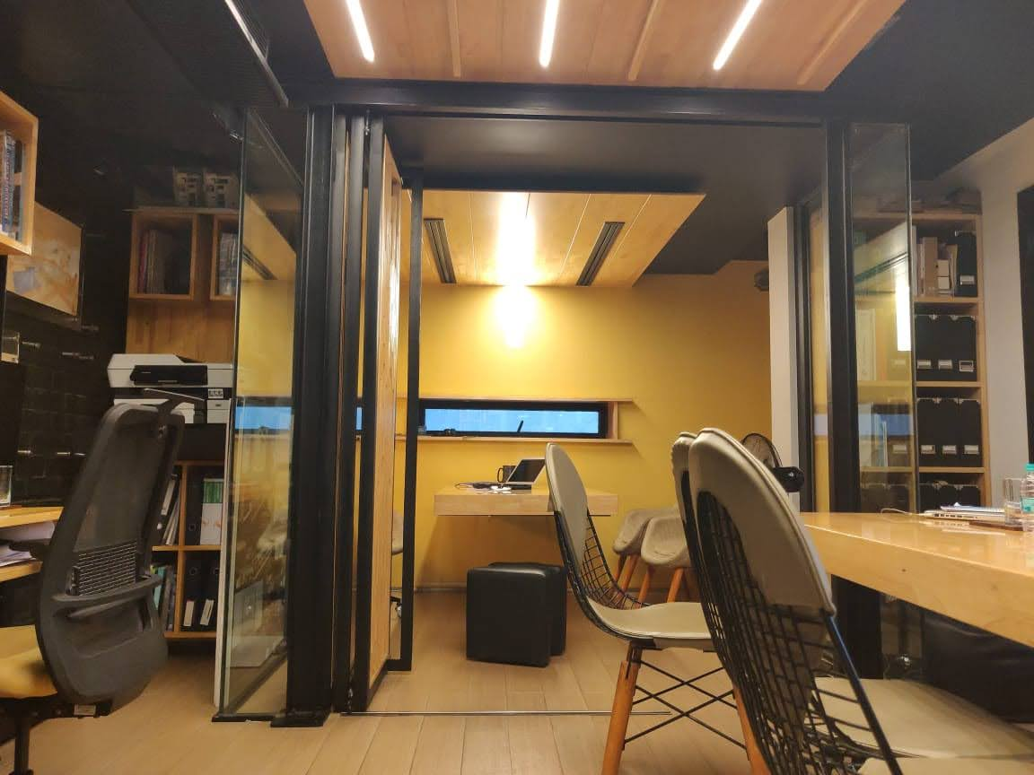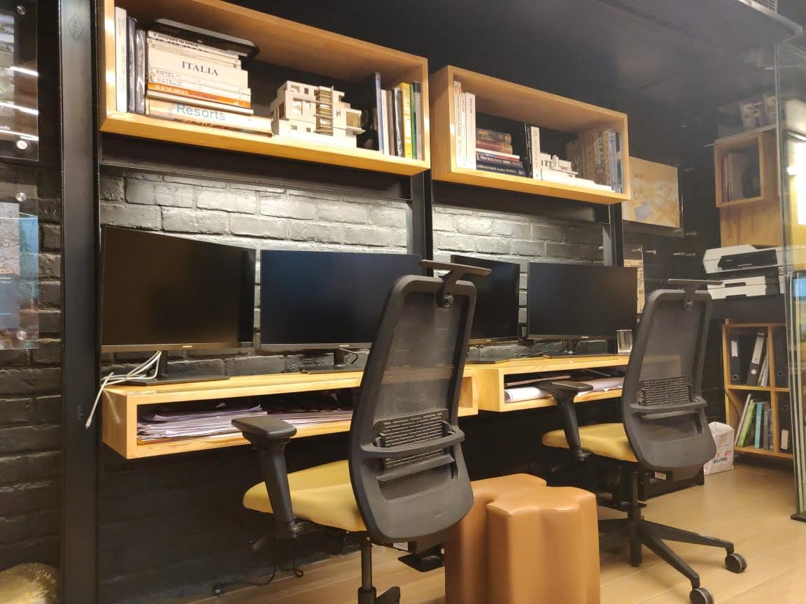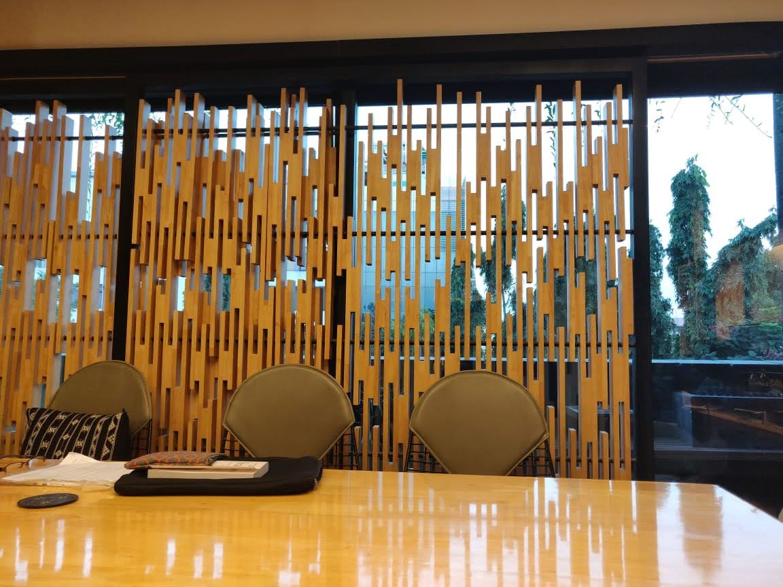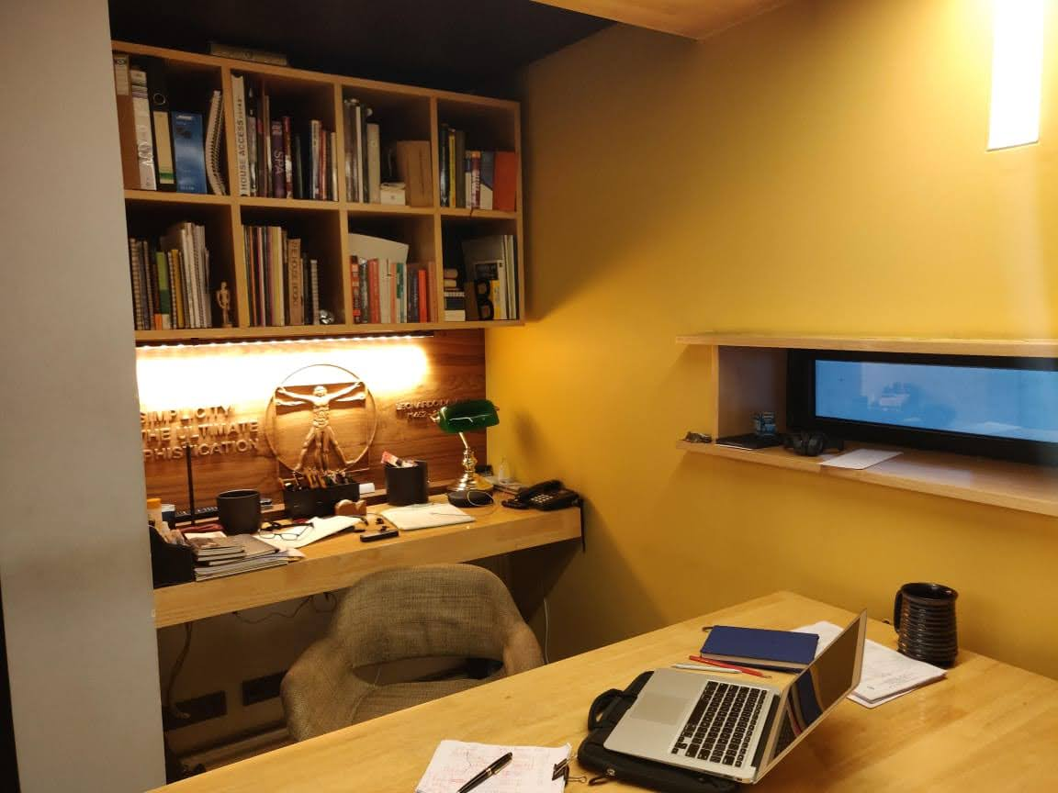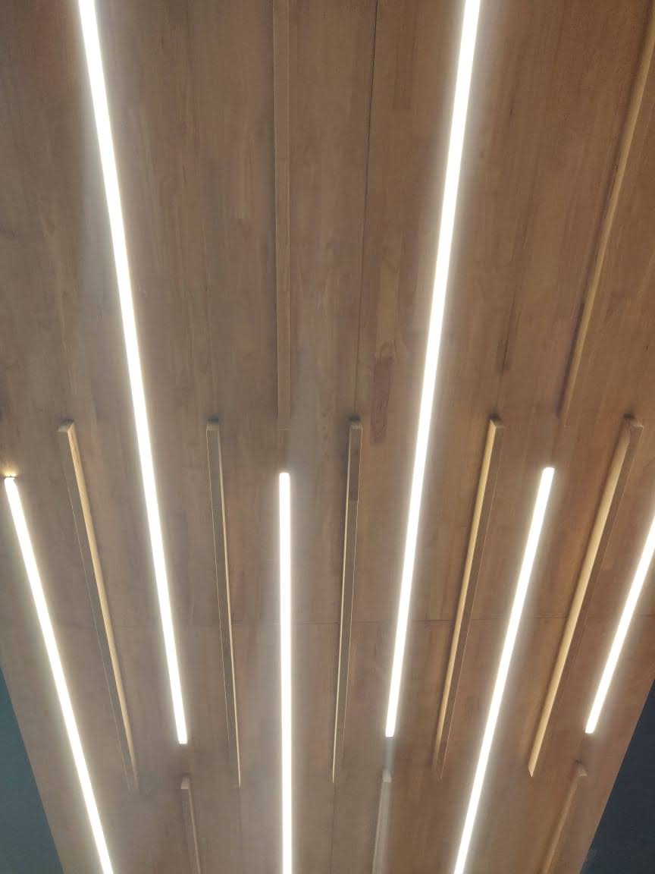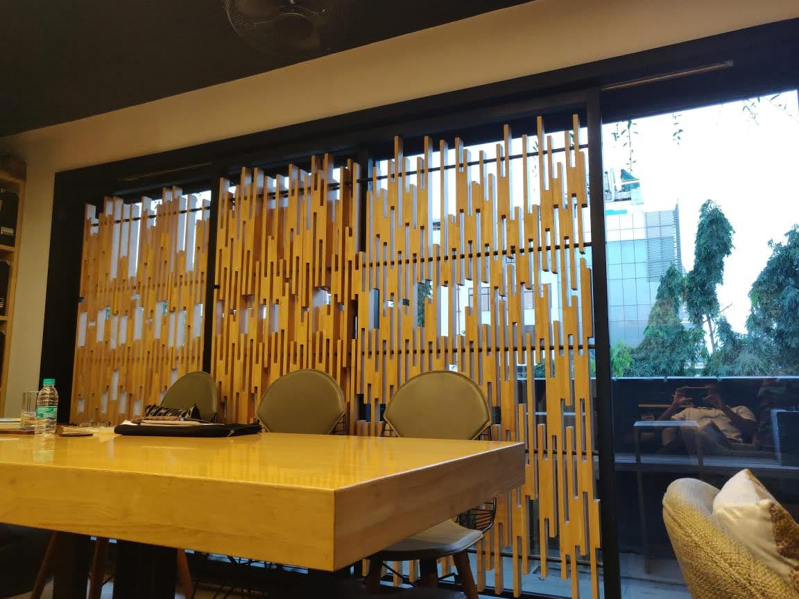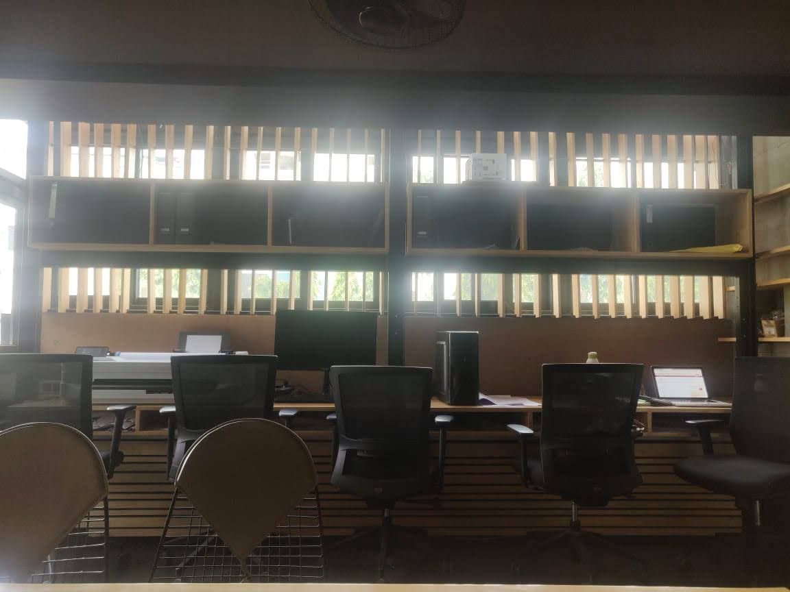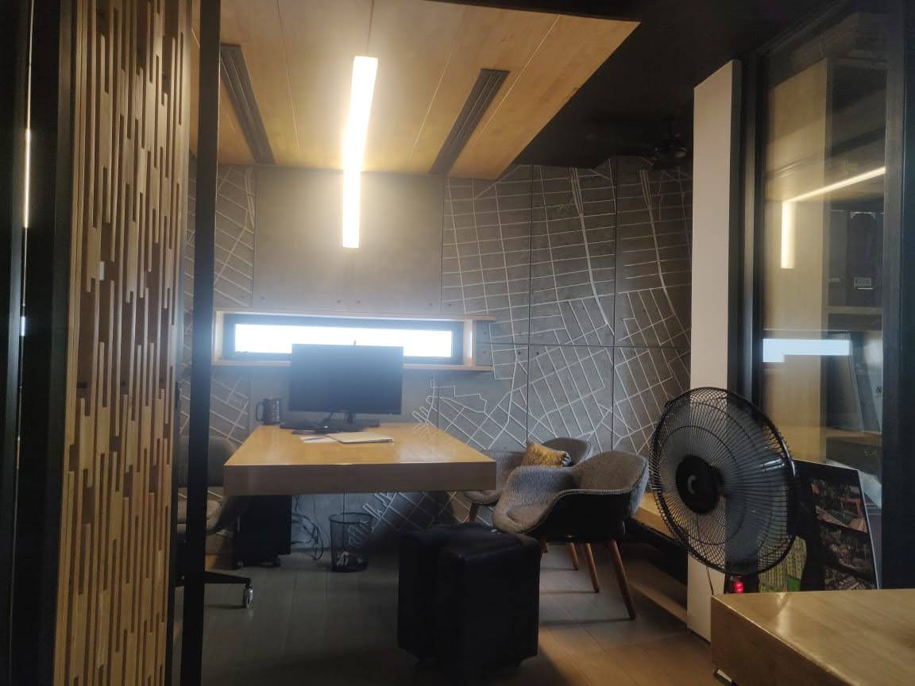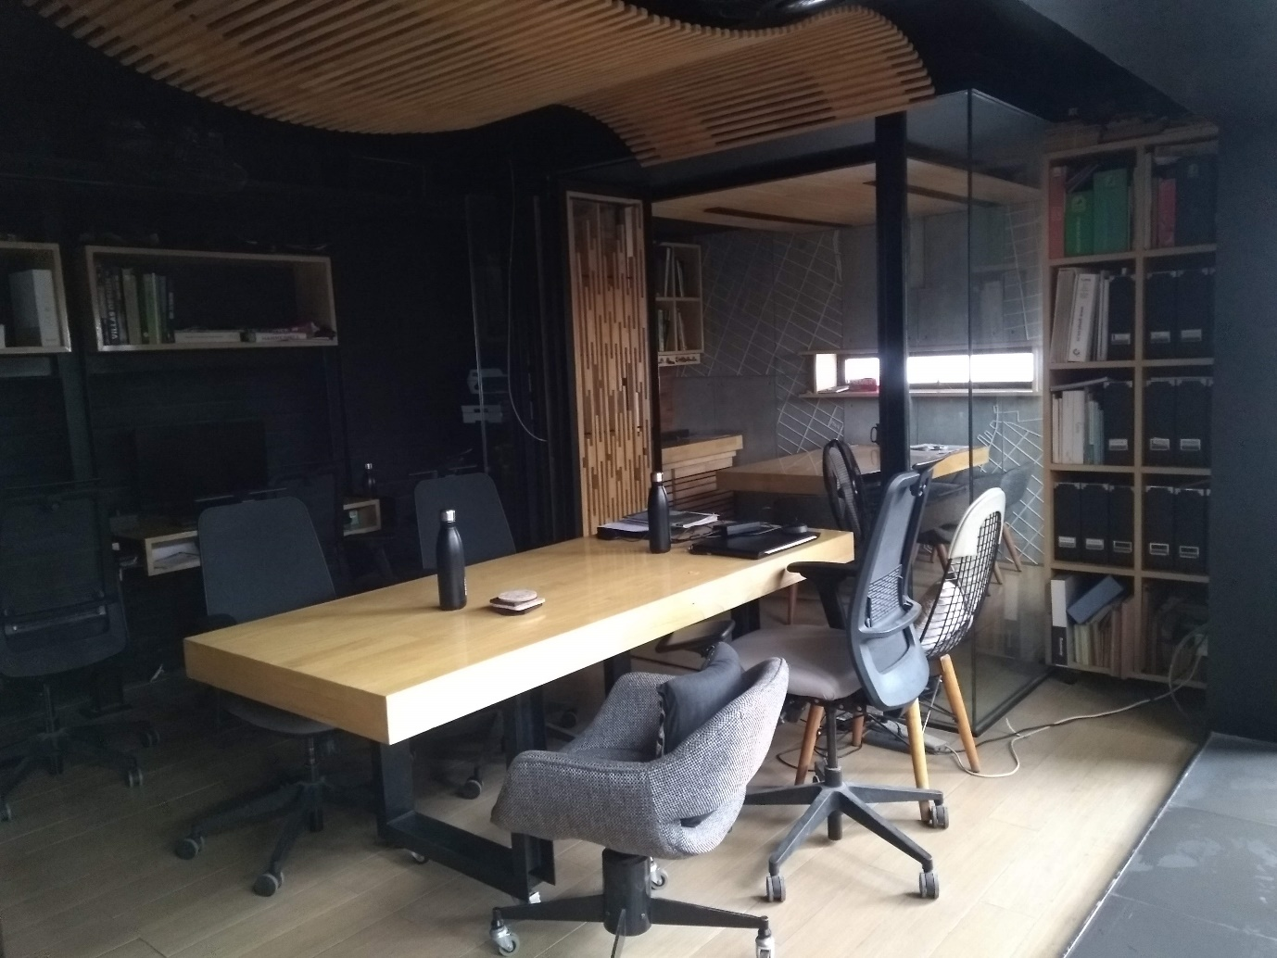

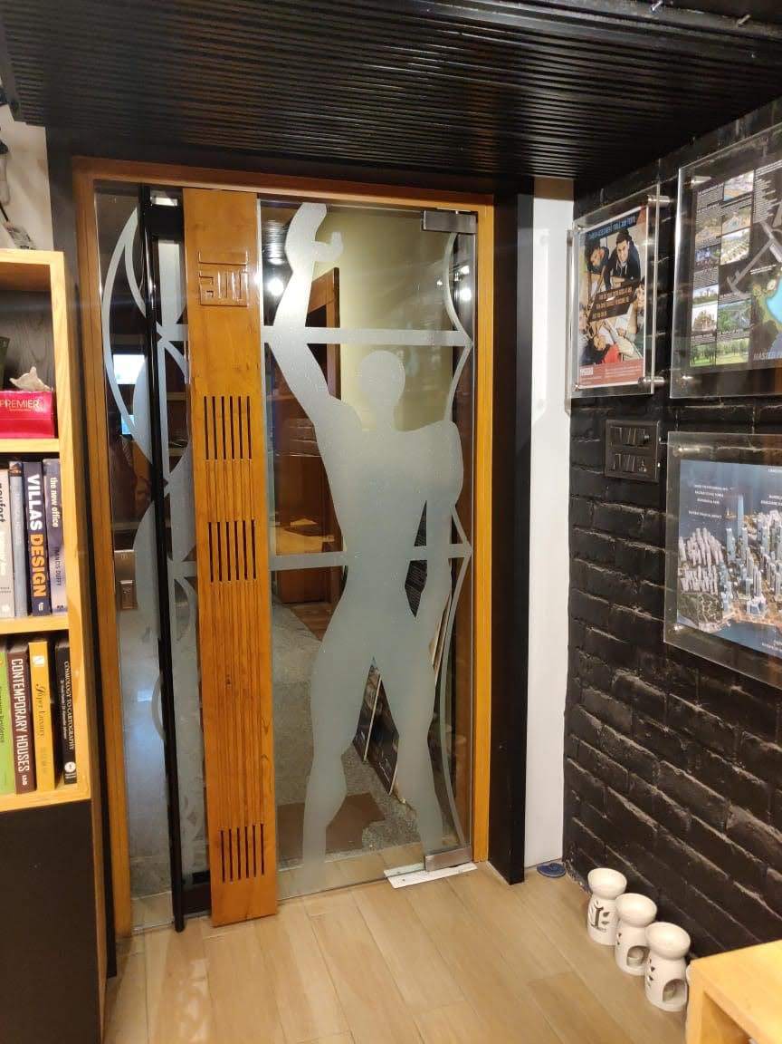

1. PAGE 2: TEAM
2. Principal architect- Ar. Mohammed Faisal

Mohammed Faisal is a Chartered Architect and Urban Designer, having over 22 years of experience in multi-disciplinary consultancies in Asia & the Middle East. Faisal’s boutique architectural practice – MOFA was established in 2016. It is a professionally focused consultancy interested in creating responsible architecture. The practice carries out applied research and investigates present and future trends that impacts design. The study on global changes in demographics has enabled MOFA to evolve a new typology in social housing. They also extensively studied the thinking patterns of Millennials, which was the premise on which a semantic shift in workspaces design for a large multinational client was undertaken.

Faisal is also a founder partner of SCDCorp, a virtual design firm offering BIM services globally. Faisal believes that SCD’s edge above others is the vast design and construction experience carried by the directors. ‘As architects, we have designed and built over 75 million square feet around the globe. We have some of the finest BIM veterans in our team with the capability of stretching BIM to its limits.’ *(Source: LinkedIn)*

1. Senior architect- Ar. Bhanu Prakash Chary

With 12 years of experience in architectural design and management of projects at various stages in diverse assignments. Attained vast experience while working with reputed architectural firms and serving the reputed international & local clients from different regions of India. Professionally competent in client interaction, space planning, construction drawings, contractor interaction, material.

Specialities: Master planning, Hi-rise Residential development

Software proficiency: AutoCAD, Revit, Structural, Sketch-up *(Source: LinkedIn)*

1. Design team /Studio
2. Interns
3. Stories/ Feedback
4. PAGE 3: PROJECTS
5. Residential-
6. Single Residences
7. Multi-residential
8. Hospitality
9. Commercial
10. Public
11. Master Planning
12. Urban Planning
13. Mixed-Use
14. Projects by Location
15. PAGE 4: CLIENTS
16. Info and company
17. Testaments
18. PAGE 5: NEWS
19. Competitions
20. Updates
21. Blog posts
22. PAGE 5: JOIN
23. Updates
24. Events and news
25. Awards
26. Research & Learning
27. Available Openings
28. Application Details

CONTACT

1. Twitter Link
2. Facebook Link
3. LinkedIn Link
4. Instagram Link
5. Address:

*#14, Level-3, Road no.10, Banjara Hills, Hyderabad, India- 500034*

1. Phone No.:

*+91 9949116218*

1. Email:

[faisal@mofa.co.in](mailto:faisal@mofa.co.in) ; [info@mofa.co.in](mailto:info@mofa.co.in) ; [studio@mofa.co.in](mailto:studio@mofa.co.in)

1. Map

**FORMAT FOR EACH PROJECT TILE**

1. Title
2. Picture
3. Date
4. Area
5. Client
6. Scope of services
7. Status
8. Location
9. Concept
10. Description

* Each tile can lead to a Blog post/ detailed description of the project.

**PROJECTS**

**MASTER PLANNING PROJECTS**

PROJECT 1:

1. Title: Raigarh Masterplan
2. Picture
3. Date
4. Area: approx. 250 Acres
5. Client
6. Scope of services: Concept Master Planning
7. Status: Design Ideation Complete
8. Location: Raigarh, Mumbai Poona High Way
9. Concept
10. Description: A pristine site having the backdrop of the Western Ghats that frames the project canvas. Natural water bodies, streams and teak plantations establish the design constraints of the project.

An accretive approach to master planning, the driveways adhere to the natural topography of the site. The entire development is walkable and the green corridors connect the various urban spaces through shaded pathways.

At the heart of the development are the water bodies, streams & green spaces that invite & compel the residents to explore the delightful environment.

The plots vary from 350 to 800 Sq. yards that are categorized to accommodate Chateaus – 5000 sq. ft. villas – 3000 Sq.ft. & Dwellings 2000 sq. ft. These serve as second homes to the buyers, mostly residents from Mumbai & Pune.

* An Equal Opportunity Employer
* Diversity & Inclusion (<https://www8.hp.com/us/en/hp-information/about-hp/diversity/culture.html>)

PROJECT 2:

1. Title: Urvi Masterplan
2. Picture
3. Date
4. Area: approx. 350 Acres for Phase 1
5. Client: Praneeth
6. Scope of services: Concept Master Planning
7. Status: Design Ideation Complete
8. Location: Hyderabad
9. Concept
10. Description: The site is a combination of thoughtful master planning and responsible landscaping. Concepts of imageability, compliance to Vastu principles, sustainable design, greener living and use of markers for the distinction of phases have been used to evolve this plan. Adopting a pragmatic approach to design, one reaches it through the grid of roads as designated by the HMDA.

A tree-lined boulevard shade every journey through the project. The development is dotted with green pockets within a distance of 100-250m from each dwelling unit. These pockets encompass small play areas and multigenerational landscapes catering to people of all age groups, from the children to the elderly.

The development, categorized into three broad sectors, comprises of countless amenities knit into the residential fabric. The western end of the site comprises of open plots with a meticulously planned stretch of bio-swales. The northern side of the site in the heart of the project sports a wide spectrum of activities ranging from healthcare and educational institutions to the convention centre and a mall. The southern end of the site comprises of compact smart villas along with the high rise and low rise apartments. This end also sports a golf course and clubhouses planned around a water body. The amenities within this development are accessible to both, residents and non-residents.

PROJECT 3:

1. Title: Madhurawada Rushikoda Masterplan
2. Picture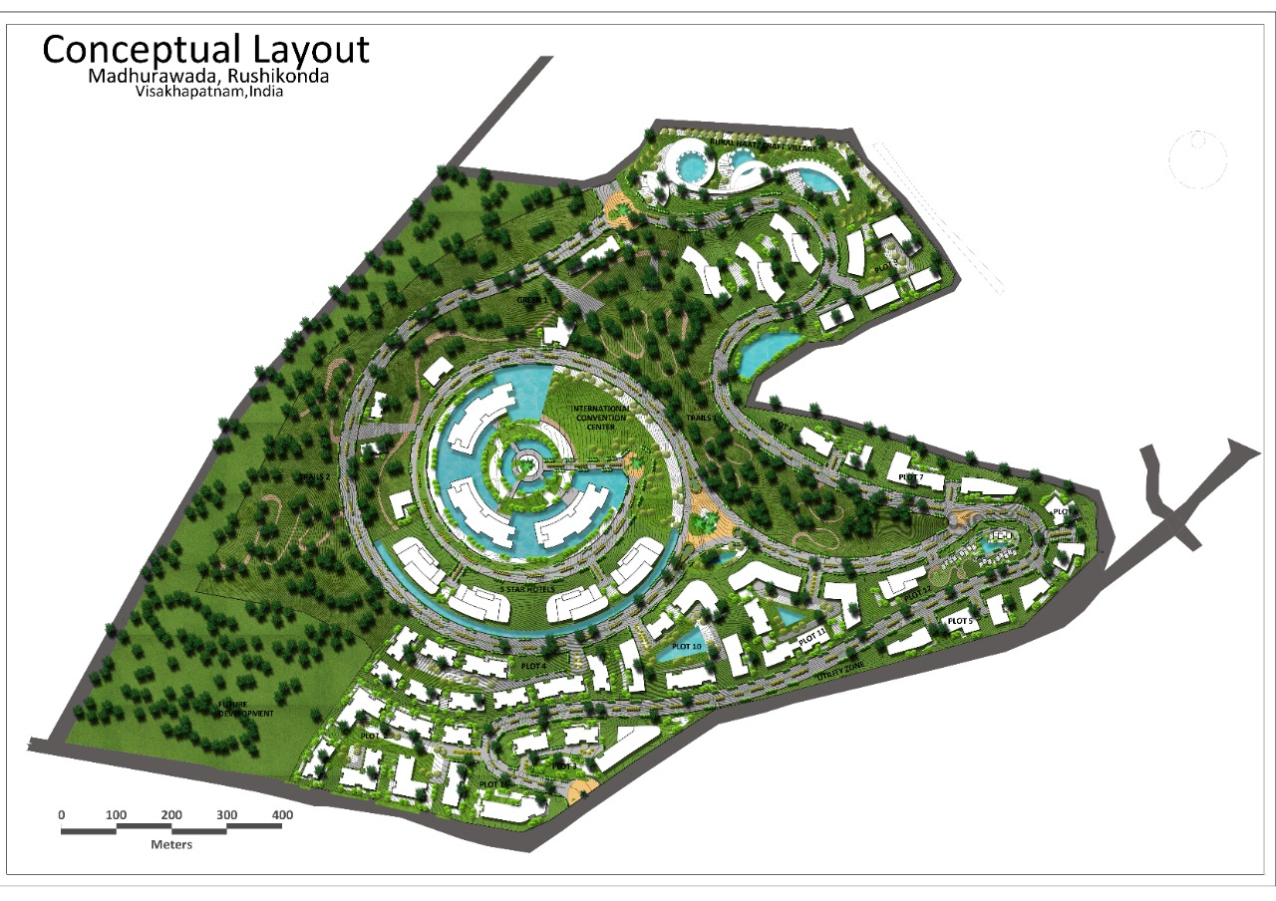
3. Date
4. Area: approx. 250 Acres
5. Client
6. Scope of services: Concept Master Planning
7. Status: Design Ideation Complete
8. Location: Raigarh, Mumbai Poona High Way
9. Concept
10. Description: The sprawling master plan showcases a unique balance between nature and the built environment. Nature trails and water bodies have been interweaved with the buildings.

The convention centre is both the focus of the site and the origin of the design. This radiates outward and gradually becomes more organic as it reaches the site boundaries. The water bed encircles the convention centre, thereby elevating the textures of the master plan. Impeccably designed roads for accessibility ensure better connectivity to the plots. The craft village on the North-east of the site showcases a plethora of activities connected to the craft community.

PROJECT 4:

1. Title: KRC Raheja Tropica
2. Picture
3. Date
4. Area: approx. 350 Acres for Phase 1
5. Client
6. Scope of services: Concept Master Planning
7. Status: Design Ideation Complete
8. Location: Ranga Reddy District, Hyderabad
9. Concept
10. Description: Nestled away from the city’s hustle and bustle, this development is close to the aircraft corridor of Hyderabad. The project is a testament to the importance of acoustics in residential design.

Dense plantation lines the edge of the site towards the airport to serve as a noise barrier. This along with acoustically treated homes creates a tranquil environment to live in away from the city.

The development is approached through an internal road connecting the main road and the dwelling units. This road provides a sense of leaving the world behind as one comes home.

The design of the project showcases compartmentalization of the site into two triangles. A safe distance of plots from the high tension line that runs across the site has also been taken into consideration in this master plan. Each of the sectors encompasses a central amenity like the clubhouse and the park.

PROJECT 5:

1. Title: Ashoka Forest Walk
2. Picture:
3. Date
4. Area: 10 Acres
5. Client: Ashoka Developers & Builders Ltd.
6. Scope of services: Concept Master Planning
7. Status: Design Ideation Complete
8. Location: Doolapally
9. Concept
10. Description: The design of this development aimed to create optimally utilized land parcels for affordable housing. An exploration of the principles of master planning, different housing typologies were experimented with to generate three options for the master plan.

The edge of the site abutting the main road is lined with plots of 267 sq. yds. The dimensions of the other plots varied from 221 sq. yds. to 300 sq. yds. An apartment complex was also proposed in one of the options.

The design aimed to ensure maximum accessibility to each plot. It also focused on interweaving the landscape into the built environment.

PROJECT 6:

1. Title: Ashoka Green Planet
2. Picture: 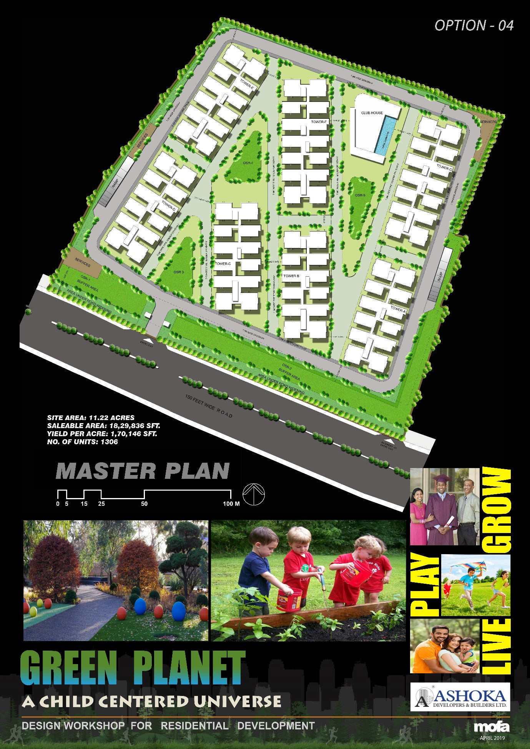
3. Date: April 2019
4. Area: 11.22 Acres
5. Client: Ashoka Developers & Builders Ltd.
6. Scope of services: Concept Master Planning
7. Status: Design Ideation Complete
8. Location: Mokila, Hyderabad
9. Concept
10. Description: Set in the upcoming and sought after residential locality of Mokila, 40kms north of Hyderabad, the project boasts of lush green foliage and well-planned connectivity. Multiple planning options focusing on establishing a good network between the buildings and their surroundings were created.

Ashoka Green Planet is a child-centric design that focuses on nurturing the spirit of a child. The project integrates open areas with blocks such that each building faces open space.

An endeavour in integrated sustainability, the midrise apartment complex blends seamlessly into its neighbourhood.

PROJECT 7:

1. Title: Ashoka Urbania
2. Picture:
3. Date
4. Area: ~14Acres
5. Client: Ashoka Developers & Builders Ltd.
6. Scope of services: Concept Master Planning
7. Status: Design Ideation Complete
8. Location: Shamshabad
9. Concept
10. Description: Shamshabad is a growing residential and commercial locality of Hyderabad with good connectivity to other upcoming environs. The Ashoka Urbania master plan is simple yet efficient.

The triangular plot provided a great opportunity to centrally place the amenities between three blocks. These towers are high rise, comprising of 15 floors each. The units are placed to achieve optimal privacy, daylighting and views.

The proposal is to have two towers with 3BHK units in three sizes, small, medium and large. These units are of areas 1538, 1615 and 1803 Sq.ft respectively. The third tower sports 2BHK units of area 1008Sq.ft, 2.5BHK units of areas 1284 and 1334 Sq.ft and 3BHK units of the area 1803 Sq.ft.

PROJECT 8:

1. Title: Bhumiraj- Navi Mumbai- Masterplan
2. Picture:

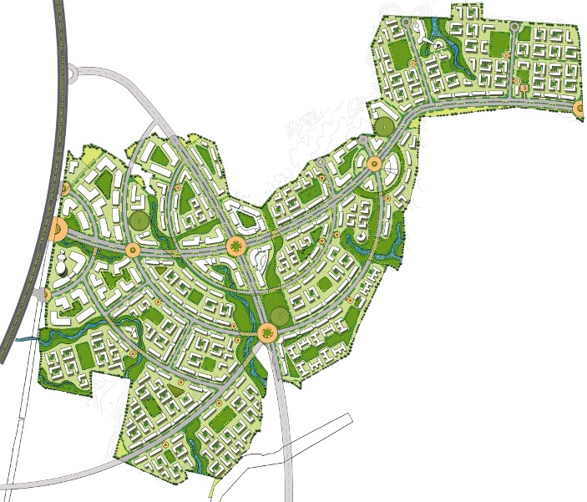

1. Date
2. Area
3. Client
4. Scope of services: Concept Master Planning
5. Status: Design Ideation Complete
6. Location: Navi Mumbai
7. Concept
8. Description: A masterstroke of planning, the Bhumiraj Masterplan is located along the Navi Mumbai-Pune Corridor. The irregular site was a challenge that was overcome by a holistic approach.

A web of roads and bio-swales is interwoven with the land parcels housing different built structures. As seen in the plan, the roads run in arcs intersecting each other at distinct angles. The junctions along the main road embody a traffic round-about to facilitate vehicular movement.

PROJECT 9:

1. Title: Forest Walk
2. Picture:

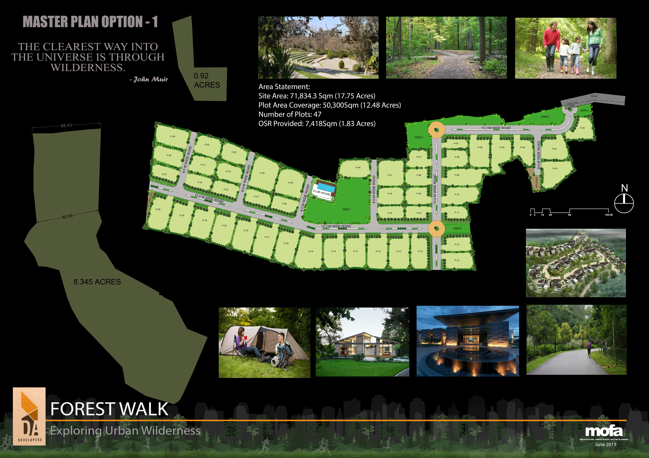

1. Date: June 2019
2. Area: 17.75 Acres
3. Client: DA Developers
4. Scope of services: Concept Master Planning
5. Status: Design Ideation Complete
6. Location: Moinabad
7. Concept: Exploring Urban Wilderness
8. Description: A collaboration to create healthy and sustainable living spaces for people to live, work and heal, Forest Walk comprises of 47 plots for residential development. Located on the outskirts of Hyderabad, Moinabad is a plotted residential development area with large parcels of land and good educational institutions.

With impeccable natural surroundings, the masterplan was aimed at optimizing the usability of the site. Two service plots are located on either end of the site and a clubhouse is located centrally for easier accessibility.

The project fosters the spirit of growing with nature as a part of the urban landscape of Hyderabad.

PROJECT 10:

1. Title: Fidesto Dhayari Master Plan
2. Picture:

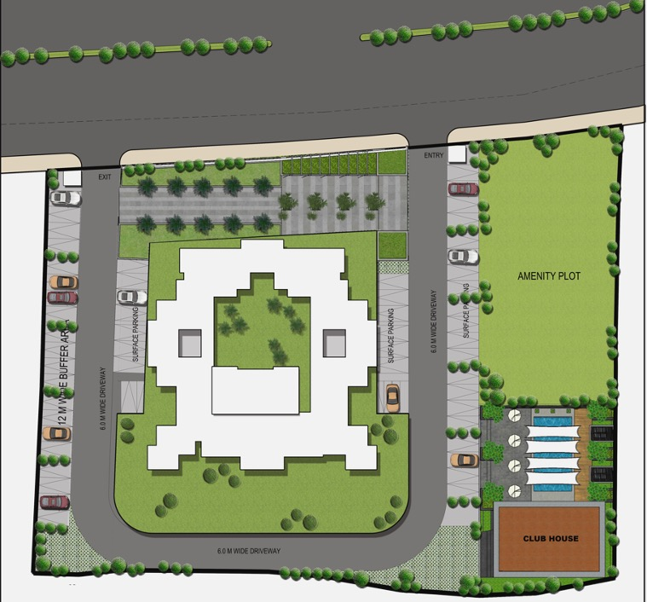

1. Date
2. Area
3. Client: Fidesto Projects Pvt. Ltd.
4. Scope of services: Concept Master Planning
5. Status: Design Ideation Complete
6. Location: Dhayari, Pune
7. Concept:
8. Description: Encompassed by scenic hills and greenscapes, Dhayari is an upcoming suburb of Pune. The staggered facade allows a play of light and shadow across all faces of the structure.

The central cutout is designed to serve as the courtyard of the residential unit and sport recreational activities. It is also the lung space of the beautifully sculpted masterplan that pours in ample amounts of light.

Services like the amenity plot, parking areas and the clubhouse flank the residential development on either side. This placement breaks the monotone on the site and provides good accessibility from all sides.

PROJECT 11:

1. Title: Indis Tropica
2. Picture:
3. Date
4. Area
5. Client: Indis
6. Scope of services: Concept Master Planning
7. Status: Design Ideation Complete
8. Location: Mokila, Hyderabad
9. Concept
10. Description:

PROJECT 12:

1. Title: Viva City Masterplan
2. 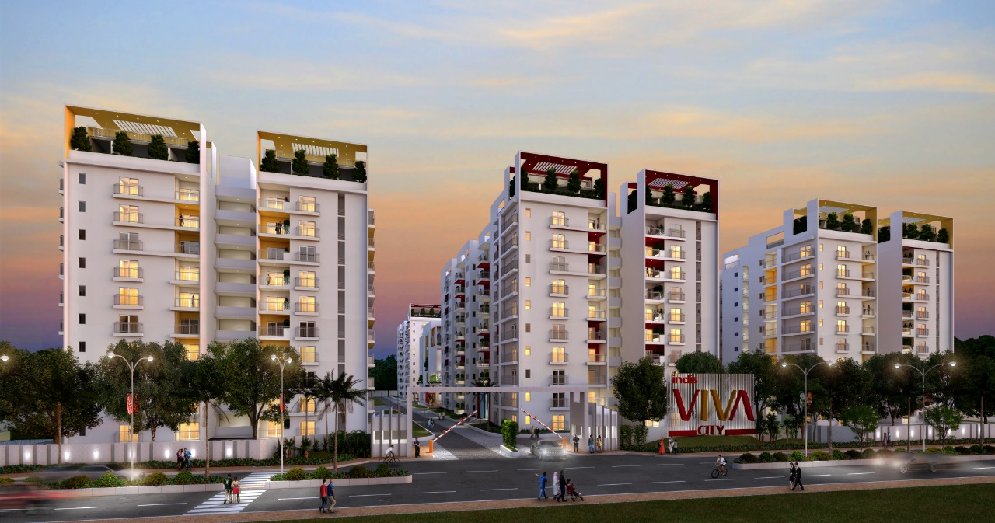Picture:

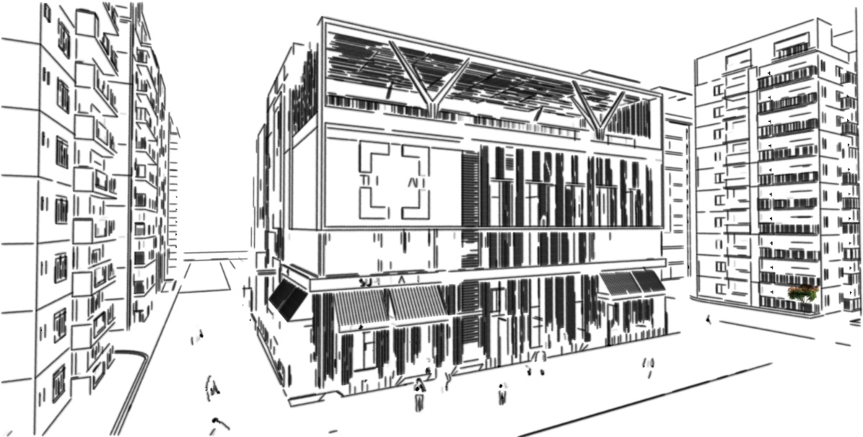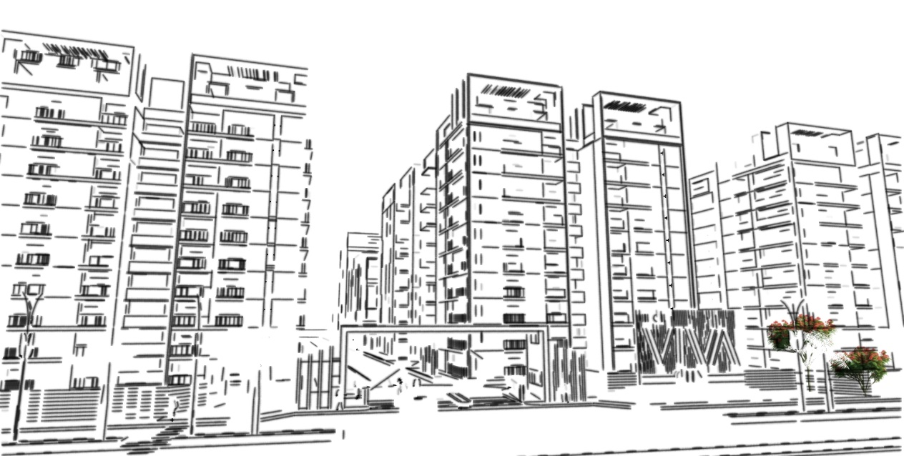

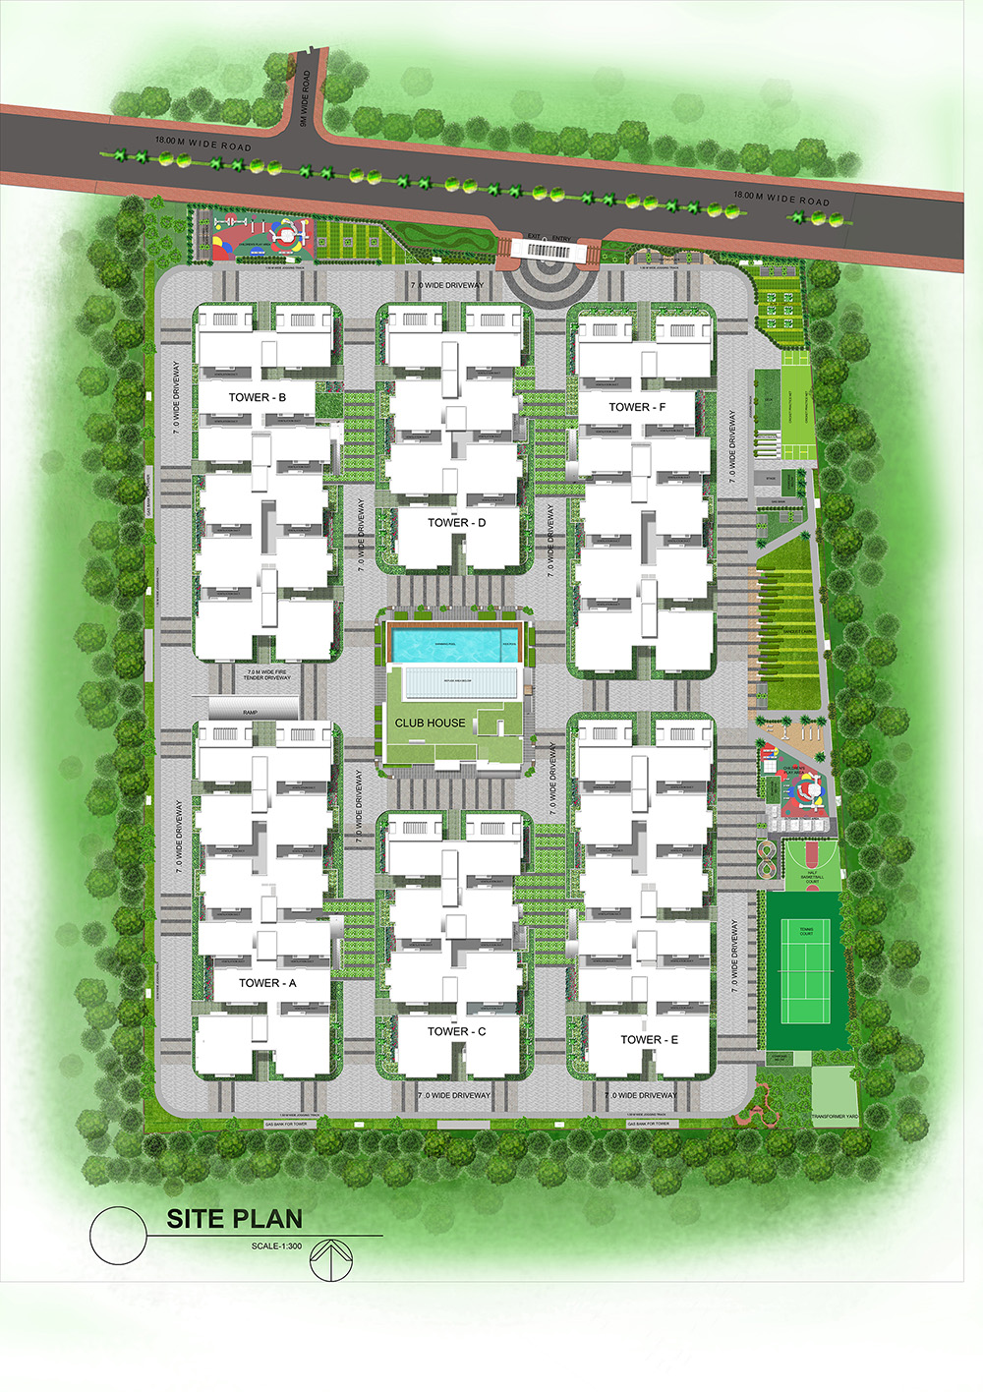

1. Date: September 2019
2. Area: 8.15 Acres
3. Client: Indis
4. Scope of services: Concept Master Planning
5. Status: Ongoing
6. Location: Kondapur, Hyderabad
7. Concept
8. Description: INDIS has provided MOFA with a brief to develop the master plan and architectural design for the Proposed Residential Development on the 8.15 Acres site situated at Kondapur, Hyderabad.

The proposed design comprises of high-rise Residential Towers, with open areas and amenities like Club House, retail spaces, gaming areas and much more. This is to achieve maximum occupancy within existing design controls that govern the site while permitting a rational and functional plan in compliance with the Local Authority Guidelines.

The design enables panoramic views of the city and landscaped areas within the development. The external landscape encompasses multigenerational spaces to cater to all age groups. Vehicular movement is restricted to the forefront of the development to provide a safe environment for pedestrian activity. The club-house represents the social, cultural and morphological core of the site.

PROJECT 13:

1. Title: Durgam Cheruvu Lakefront
2. Picture:

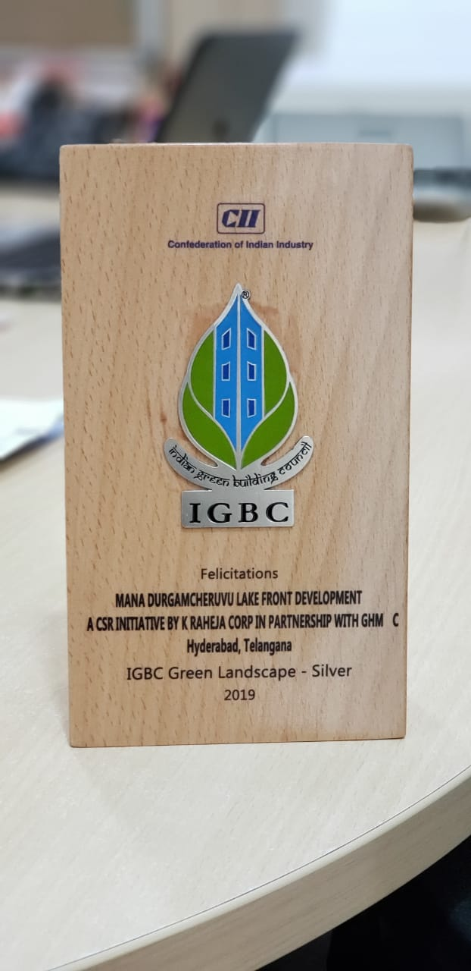



1. Date: June 2019
2. Area
3. Client: KRC Raheja
4. Scope of services: Concept Master Planning
5. Status: Project Complete
6. Location: Hyderabad
7. Concept: Redefining the Lakefront
8. Description: Mofa Architects won the competition for the design and rejuvenation of the Durgam Cheruvu Lake, organized by the Telangana State Government.

Recipient of the IGBC Green Landscape Silver award, the Durgam Cheruvu Lakefront is the recreation of Heaven on Earth. An eco-sensitive and pragmatic masterplan, the waterfront is strongly influenced by sociocultural, economic and political factors.

The rocky and uneven site terrain posed many challenges. To solve this, an all-round pedestrian pathway was laid first and then the subsequent spaces were allocated. The projects boasts of rock gardens, immersion ponds, yoga corners, bicycle tracks, cafes and play spaces among many other spaces. The masterplan has preserved and cleverly integrated the Mosque into the design.

The highlight of this development is the extra-dosed cable stayed bridge, first of its kind in the state. The cables being used for the bridge have been tested in a special lab at Germany. The advantage of using extra-dosed technology helps in reducing the pylon height from 75m to 57m. The reduced height of pylons reduces the dominance of the structure on the local ambience. The iconic bridge is being constructed by L&T Construction. Once completed, this bridge will be the third largest in the world and will have longest span in the country

PROJECT 14:

1. Title: Mindspace Campus
2. Picture:

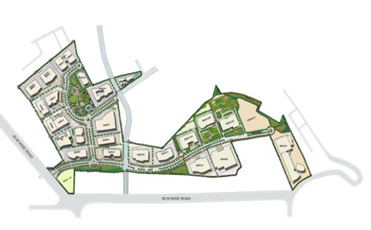

1. Date
2. Area
3. Client: KRC Raheja
4. Scope of services: Concept Master Planning
5. Status
6. Location
7. Concept
8. Description: The Mindspace campus is connected to, but not along the main road. A new take on master planning, the plan proposed non rectangular blocks placed in optimal proximity to each other.

The plot is dotted with parks and open areas to promote good health and time spent in nature. Asymmetrical in plan, the site has triangular portions spreading in different areas.

PROJECT 15:

1. Title: Raheja Vistas
2. Picture:

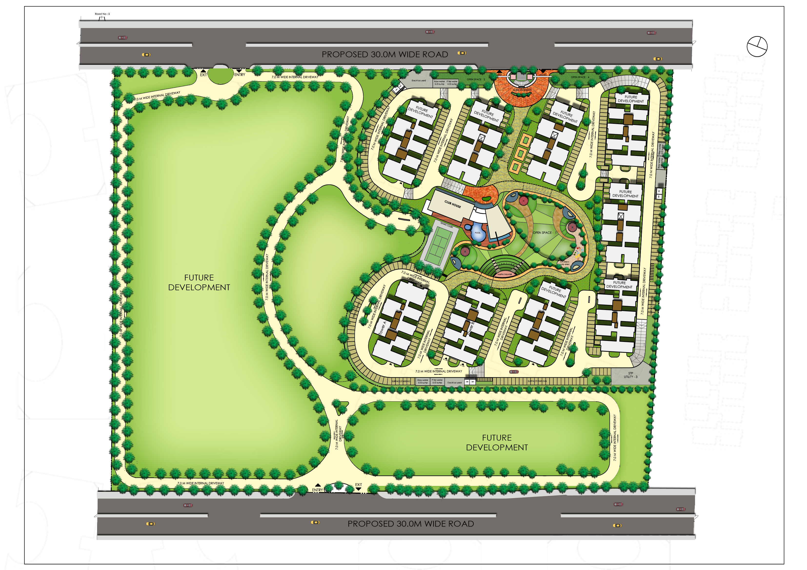

1. Date
2. Area
3. Client: KRC Raheja
4. Scope of services: Concept Master Planning
5. Status
6. Location
7. Concept
8. Description: A phase wise development, Raheja Vistas is designed to support a dense population. The plan comprises of 9 high to midrise towers encompassing activity spaces.

The orientation of the buildings is to veil the functional areas from the main road and make the blocks the focus of the moving public. Two segments of the site have been left for future development.

As a result of this, phase 1 enjoys picturesque views and large open grounds to play in. The amenities seen in phase 1, like the club house, OAT, swimming pools and the playing courts will be common to the other phases as well to promote community interaction and social growth.

PROJECT 16:

1. Title: KRC School
2. Picture:

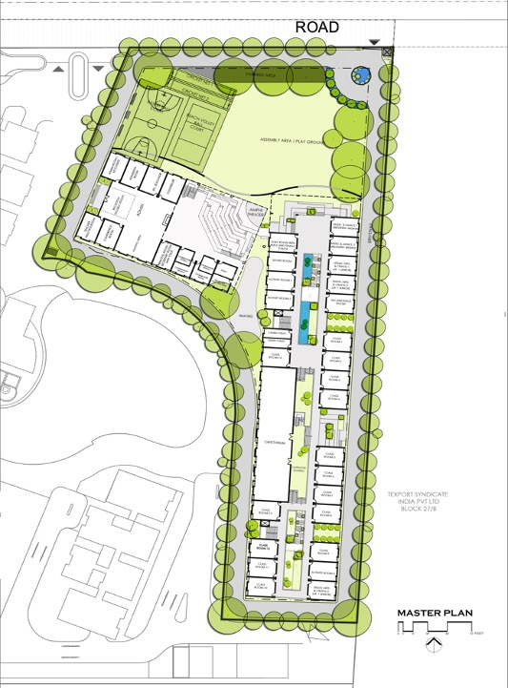

1. Date
2. Area
3. Client: KRC Raheja
4. Scope of services: Concept Master Planning
5. Status
6. Location
7. Concept
8. Description: A space for nurturing the souls of tomorrow, it is imperative to design schools that boost academic performance and all-round wellbeing of a child. KRC School’s masterplan showcases the deeper understanding of this statement.

A driveway, accessed from the main road, lines the periphery of the site followed by the blocks serving different functions. The leftover areas were to be converted into hangout spots, green stretches and ponds for the children.

Keeping in mind the traditional requirements, an assembly space was placed at the entrance of the blocks, which could be used as a playing ground at recess. Aside from this, the plan also exhibits cricket nets, basketball court and a volleyball court to promote the spirit of sports in the children.

A well thought plan, the KRC school masterplan looks into the finer details of how architecture can shape education.

PROJECT 17:

1. Title: Image tower
2. Picture:
3. Date
4. Area
5. Client: KRC Raheja
6. Scope of services: Concept Master Planning
7. Status
8. Location
9. Concept
10. Description:

PROJECT 18:

1. Title: IT Raidurg- Hetero Masterplan
2. Picture:
3. Date
4. Area
5. Client: KRC Raheja
6. Scope of services: Concept Master Planning
7. Status
8. Location
9. Concept
10. Description:

PROJECT 19:

1. Title: Pocharam Masterplan
2. Picture:
3. Date
4. Area
5. Client: KRC Raheja
6. Scope of services: Concept Master Planning
7. Status
8. Location
9. Concept
10. Description:

PROJECT 20:

1. Title: Praneeth Navjeevan Master Plan
2. Picture:
3. Date
4. Area
5. Client: Praneeth
6. Scope of services: Concept Master Planning
7. Status
8. Location: Velimela, Hyderabad
9. Concept
10. Description:

PROJECT 21:

1. Title: Vajra's Pride Masterplan
2. Picture:
3. Date
4. Area: 13 Acres
5. Client
6. Scope of services: Concept Master Planning
7. Status
8. Location: Hyderabad
9. Concept
10. Description:

PROJECT 22:

1. Title: Pre-Clinical Research Organization
2. Picture: 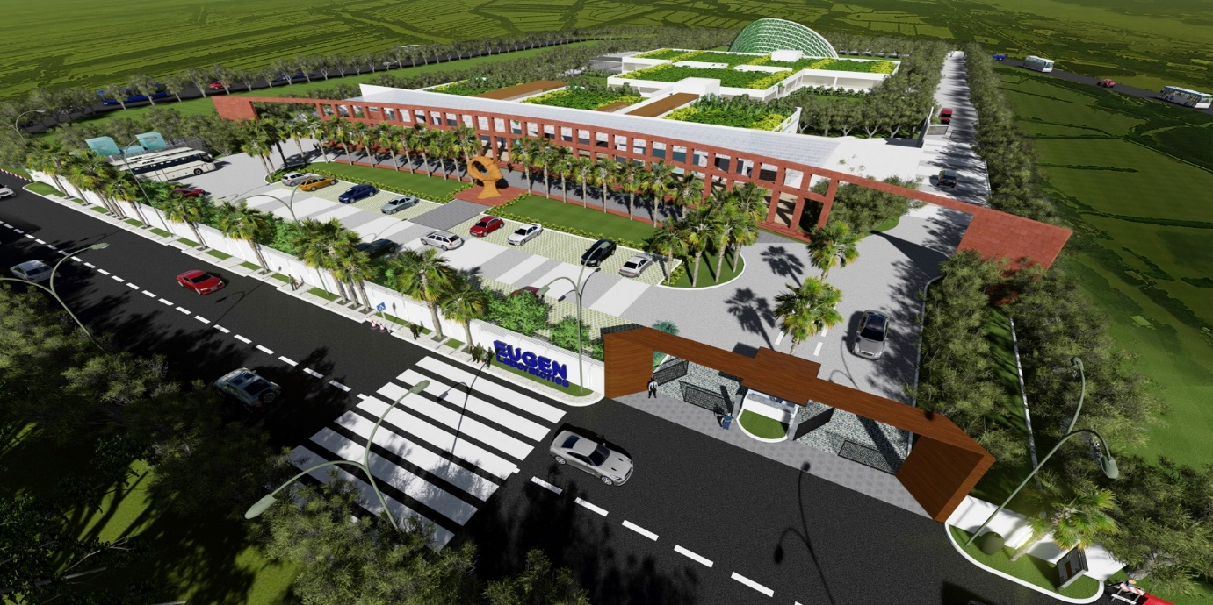

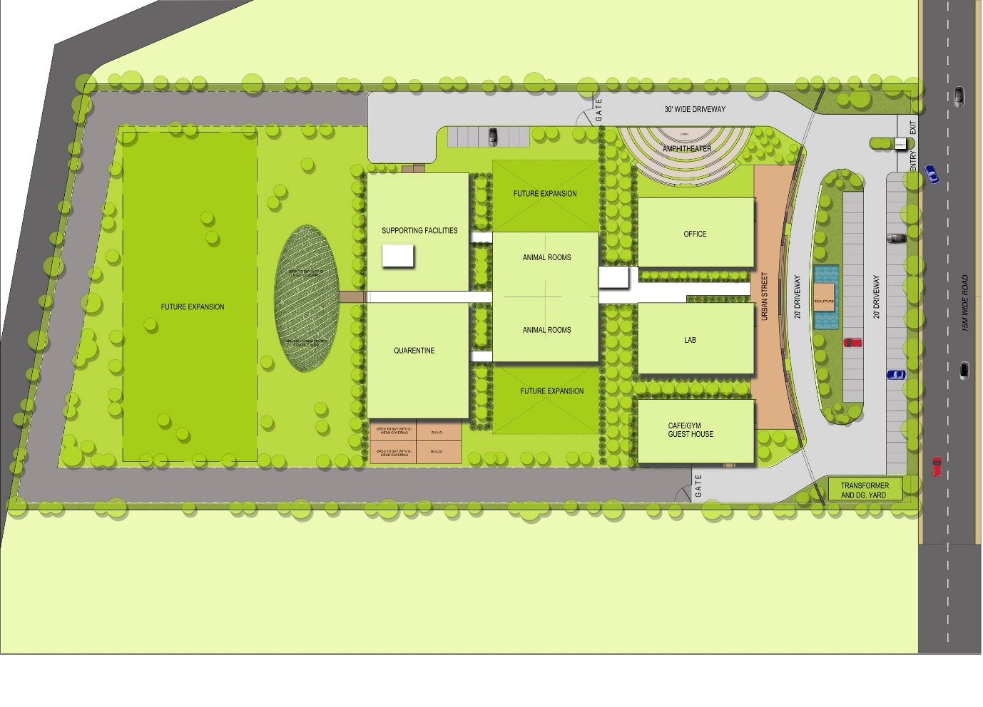

1. Date: September 2017
2. Area: 6.64 Acres
3. Client: Eugen Laboratories Pvt. Ltd.
4. Scope of services: Concept Master Planning
5. Status: Design Ideation Complete
6. Location: Vizag
7. Concept
8. Description: Located away from the city, the Eugen Lab. Pvt. Ltd. Pre-Clinical Research centre masterplan is developed with precision and care. Every little detail, right from the optimal luminosity to the unhindered circulation was designed meticulously.

The plan showcases clinical trial rooms, a R&D department, waste management rooms, a rehab centre, a corporate office and primate support area.

PROJECT 23:

1. Title: Kalakriti Artqbe
2. Picture: 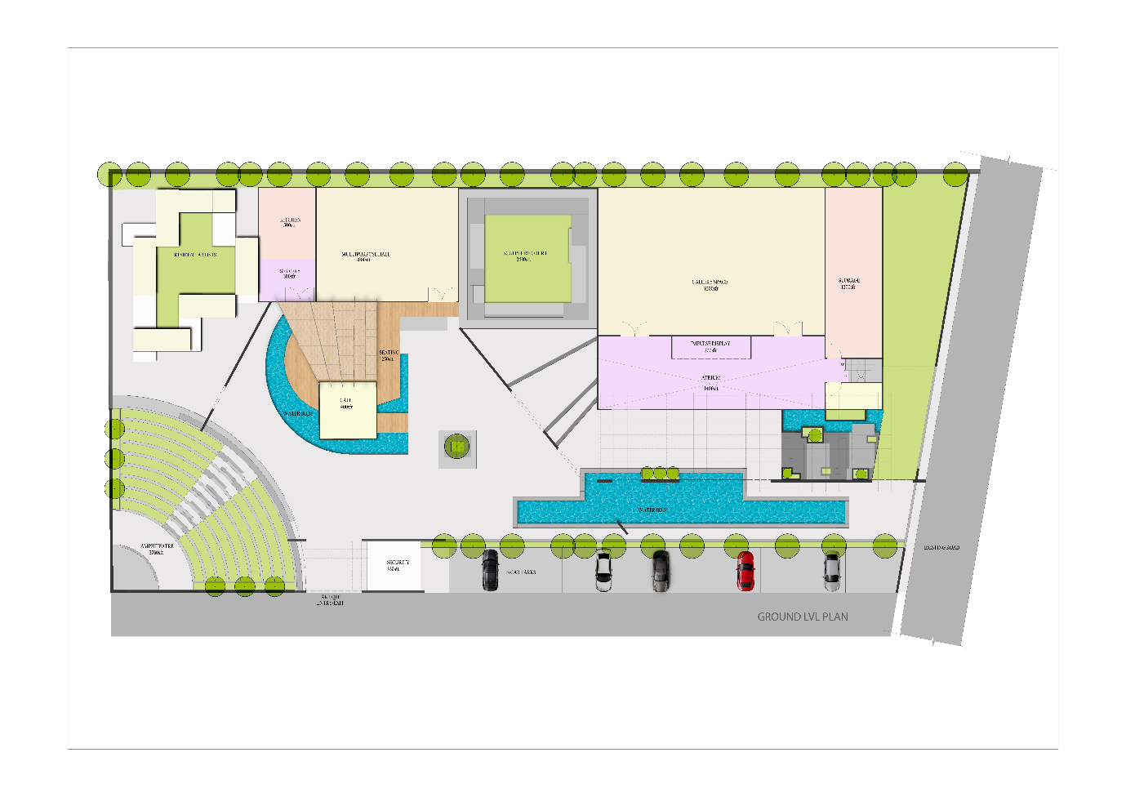
3. Date
4. Area
5. Client
6. Scope of services
7. Status
8. Location: Hyderabad
9. Concept
10. Description: The expression of creativity is called art. Architecture, in its myriad forms, is the articulation of this creativity. Kalakriti Artqbe is an art gallery that sought to uplift and provide a platform for art, artists, artisans and their admirers.

Mofa Architects developed the masterplan in line with this ideology. Responsive to the needs of the artist community, residences for on-site artists were integrated with display spaces. This gave the artists the opportunity to create and showcase their talent in the same vicinity.

Outdoor public spaces like the amphitheater and café were placed in between the residences and the gallery to invite spectators to experience both worlds of an artist’s life.

**CONCEPT FOR PROJECTS**

PROJECT 1:

1. Title: The Urban Spine as a Social & Spatial Connector

(The Case of Ramappa Lake & Temple)

1. Picture: 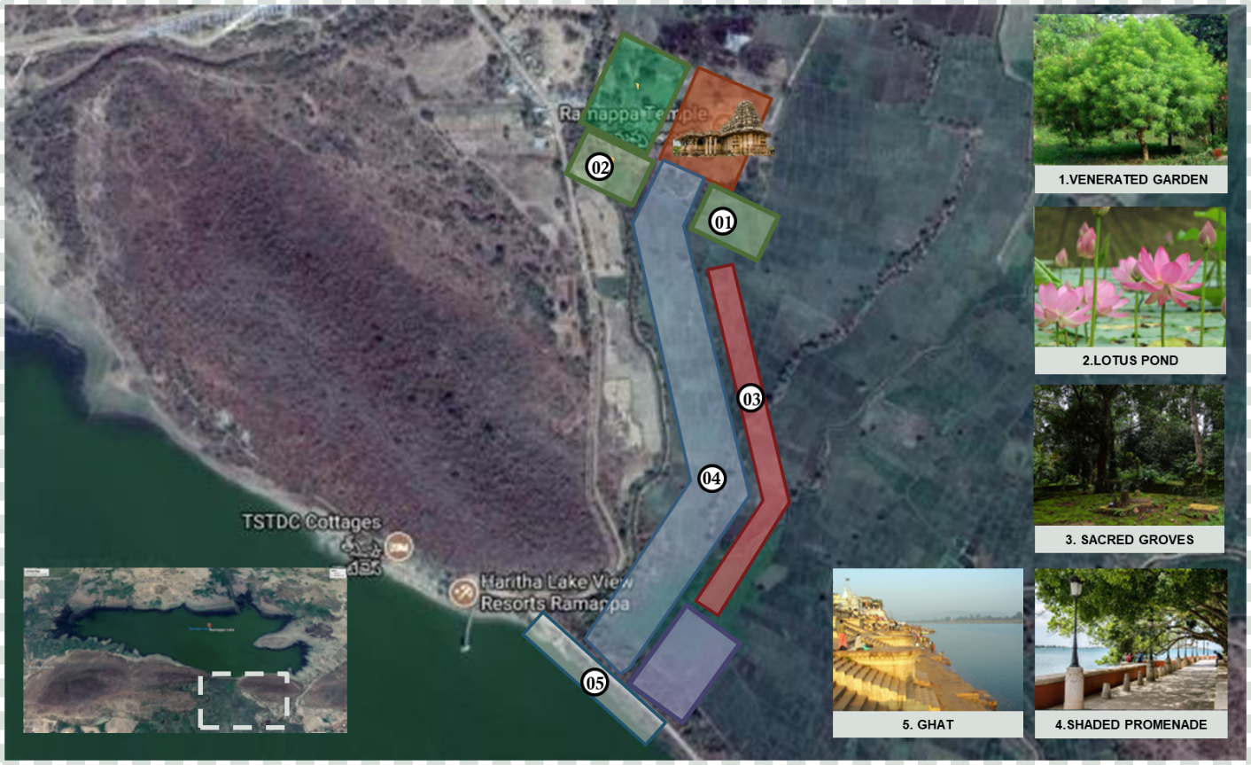
2. Date
3. Area: 82 Acres
4. Client
5. Scope of services: Concept Planning
6. Status: Conceptual Design Complete
7. Location: Warangal
8. Concept
9. Description: The Ramappa Lake and Temple were built by a Kakatiyan ruler in the 13th Century. The purpose of building a lake 1km from the temple was to provide irrigation to the local farmers and serve as a recreational spot for the village folk.

The conceptual masterplan, as designed by Mofa Architects, binds the temple and the lake together through a shaded promenade. A venerated garden, a lotus pond and sacred groves have also been proposed.

The garden is to grow plants used for worship and the groves are communally protected fragments of forests which have significant religious importance to the local folk. The plan also suggested the use of a stepped ghat to provide easy access to the lake for ritualistic purposes.